BIG DATA ANALYTICS PROJECT

**LIKELINESS TO ATTEND A CLASS**

**BY:-**

Rishi Kesav Mohan - 2017103031

Deepak S P - 2017103520

**Description:**

We have collected the data regarding the likeliness of students to attend the class via Google Forms. We have received 100 responses. We have done clustering and classification for these dataset.

The classification done here is

* ZeroR classifcation

The clustering methods handled here are

* Density clustering
* K-means clustering

We have performed classification and clustering for all each and every questions in the survey. The questions are mentioned below.

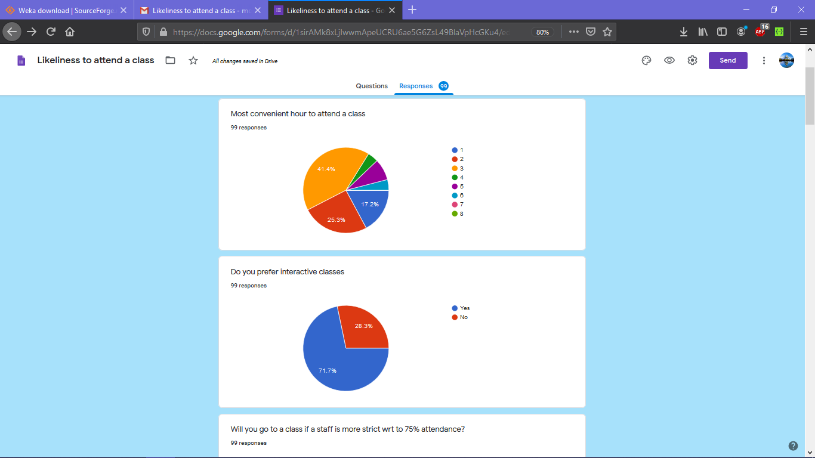

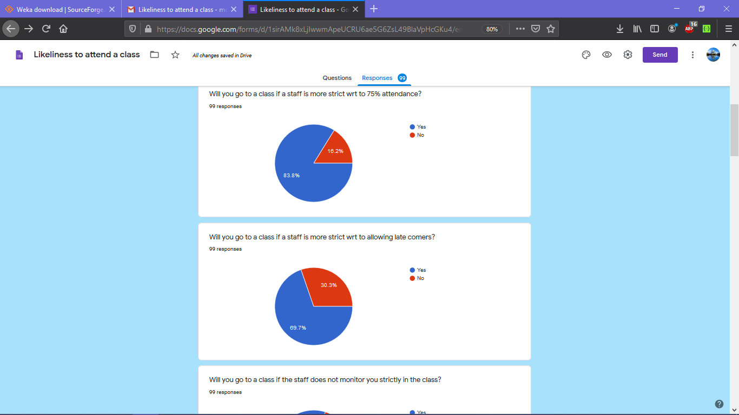

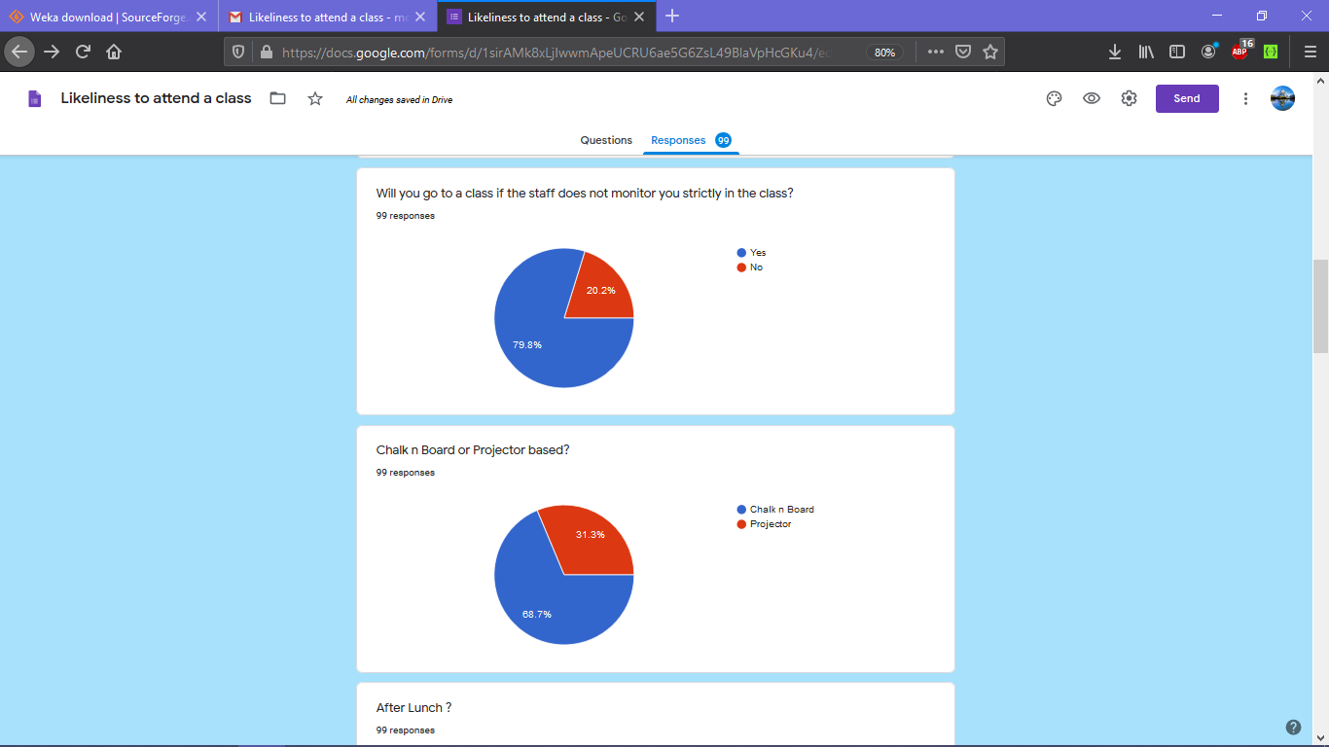

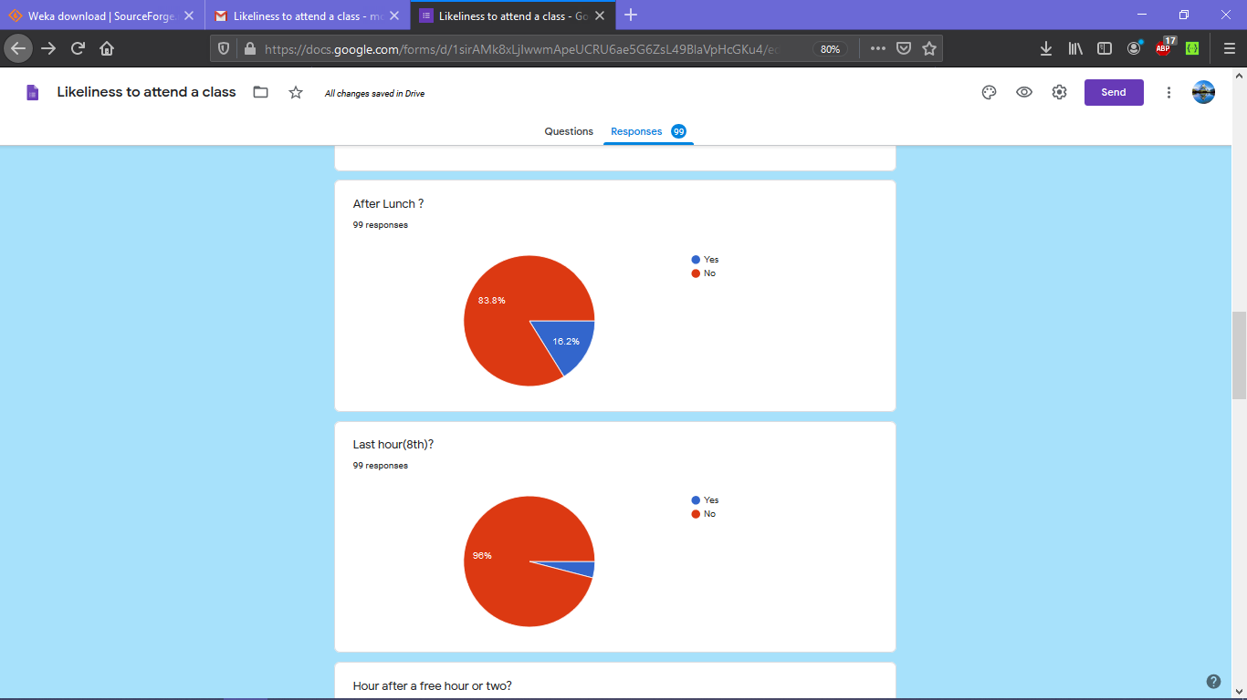

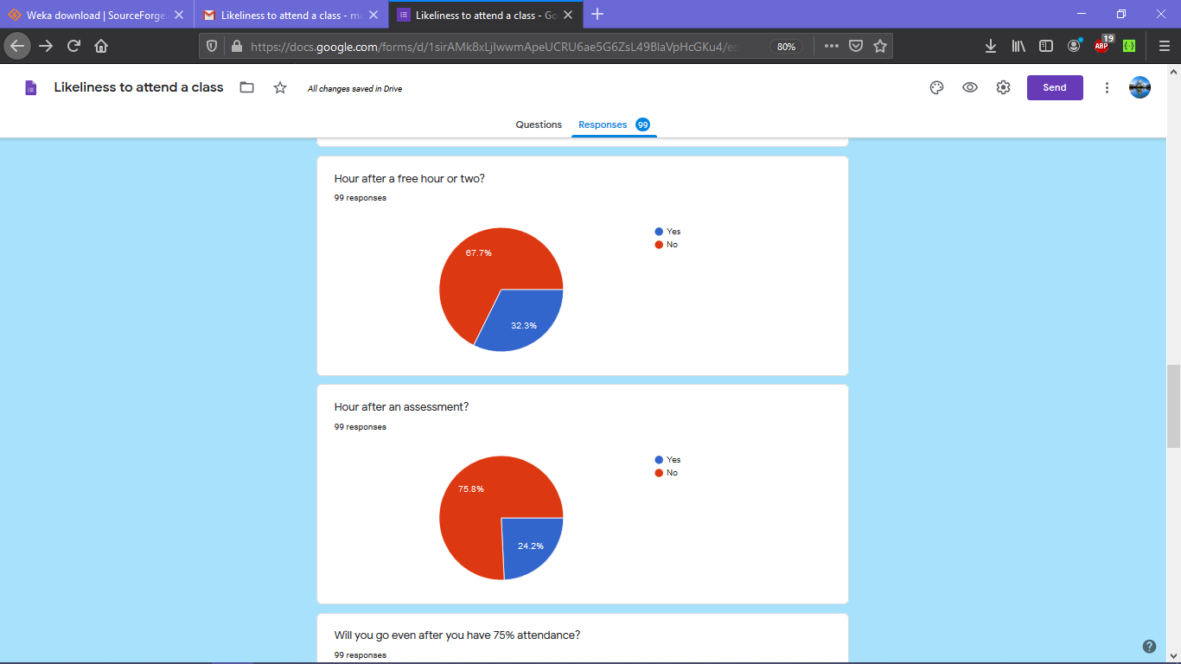

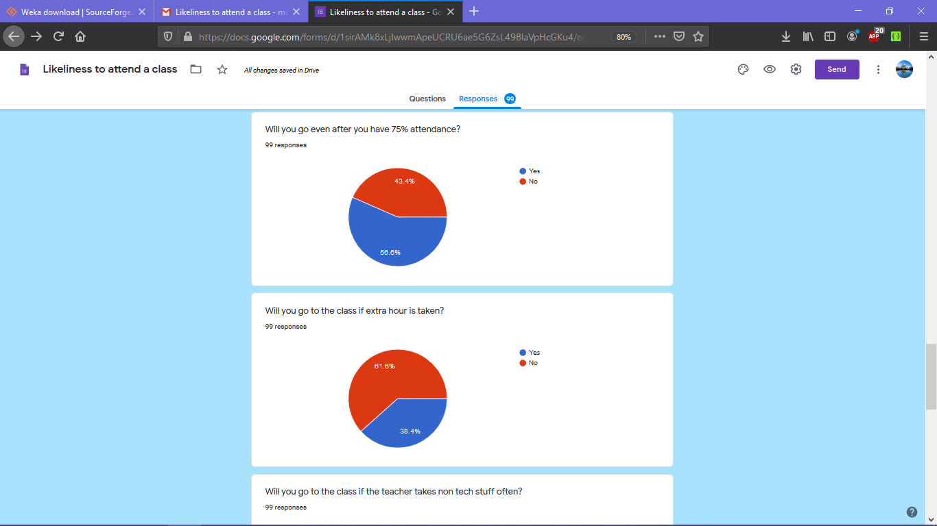

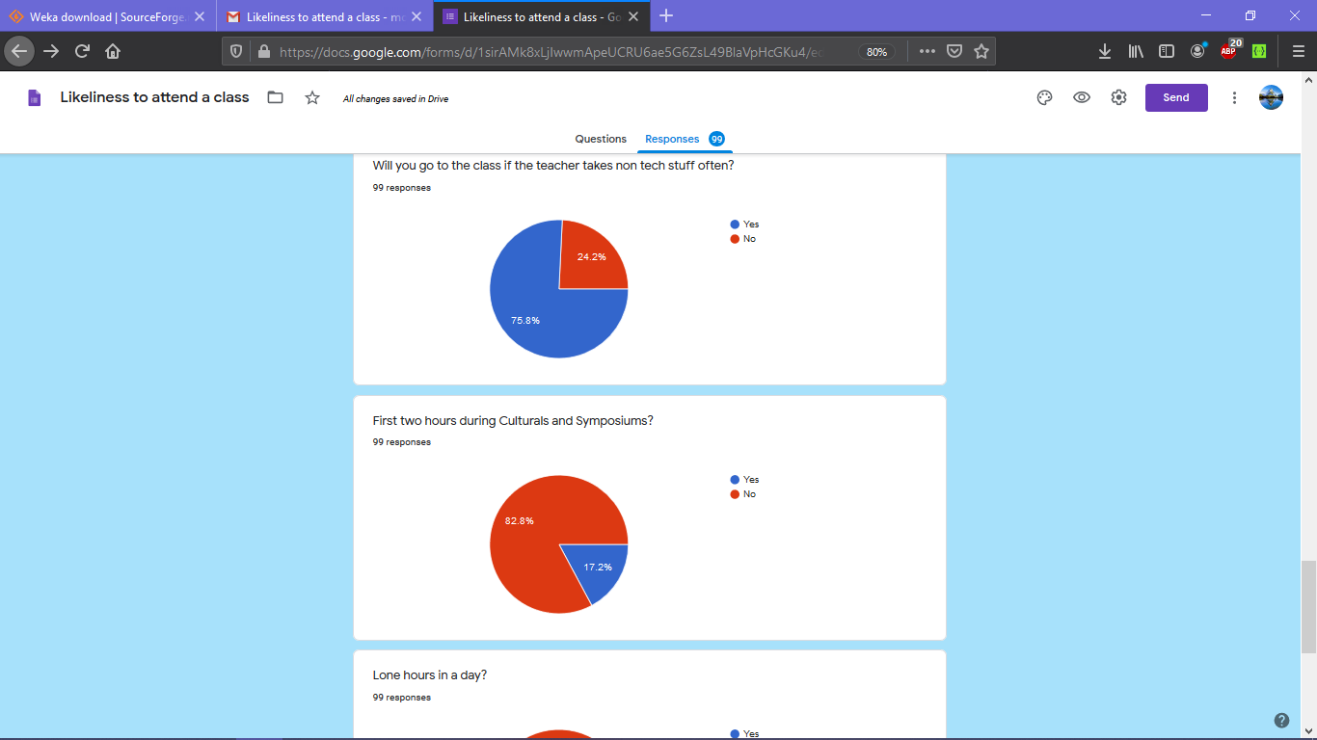

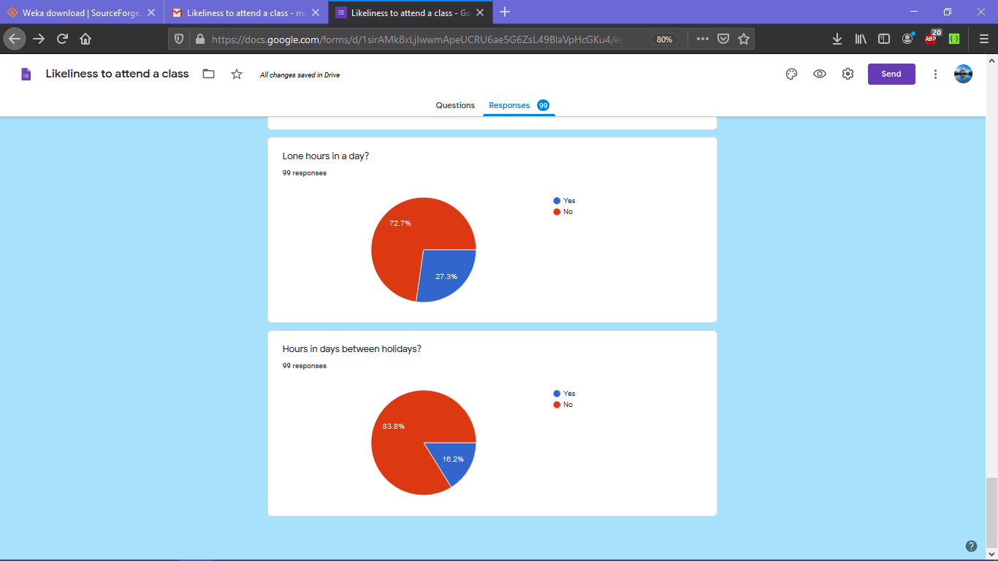

**Clustering :**

We have done two kinds of clustering for the data based on all questions. Both the clustering methods yielded almost same clusters.

Tool used : Weka Workbench

The following are the results of density clustering of the aquired dataset.

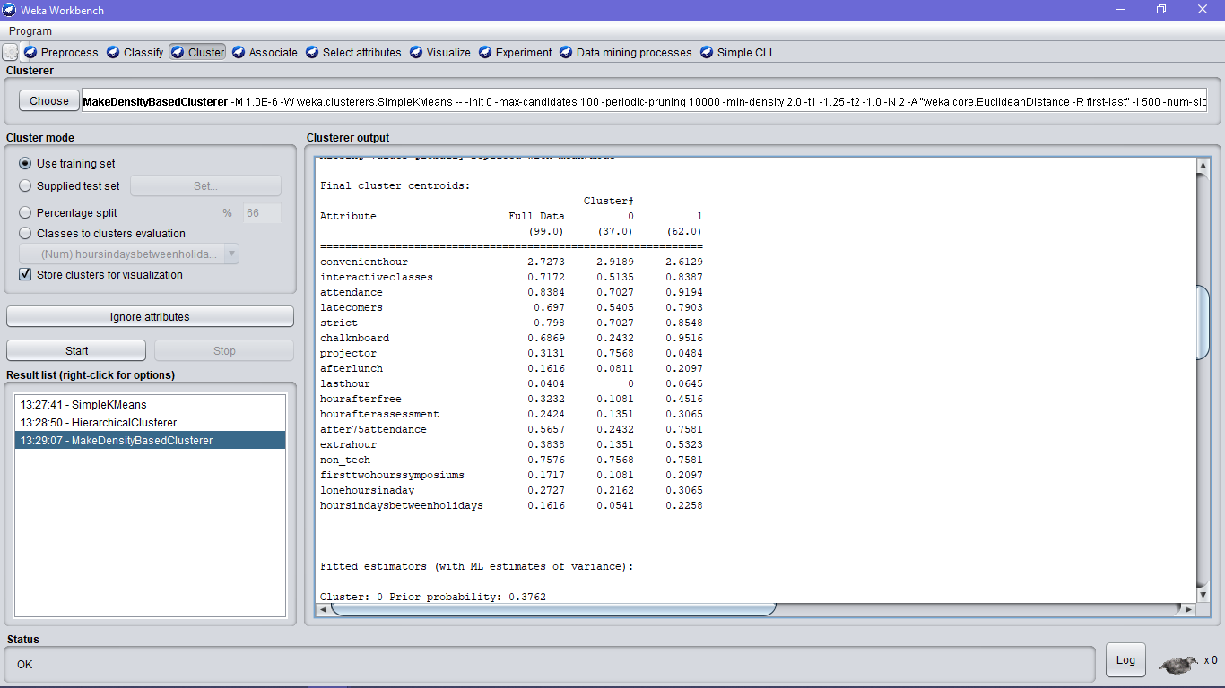

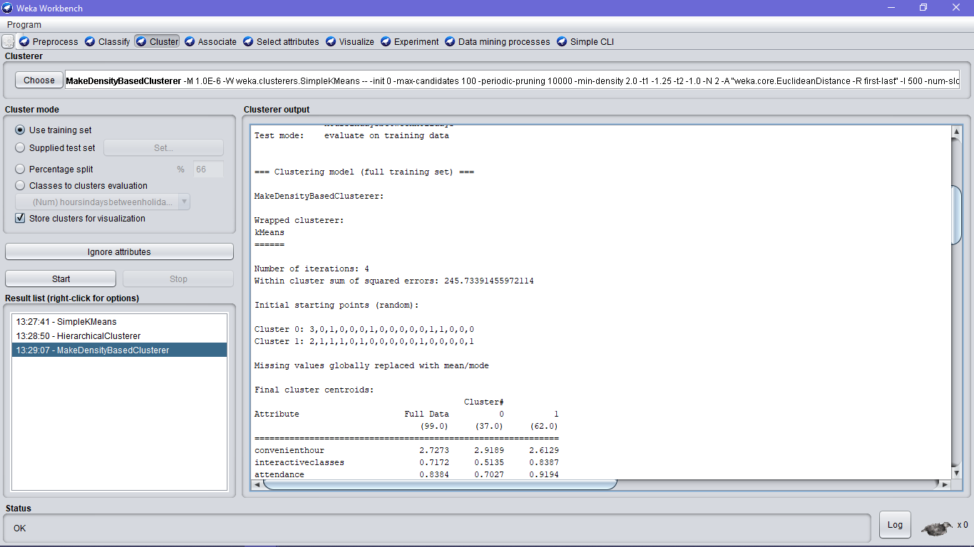

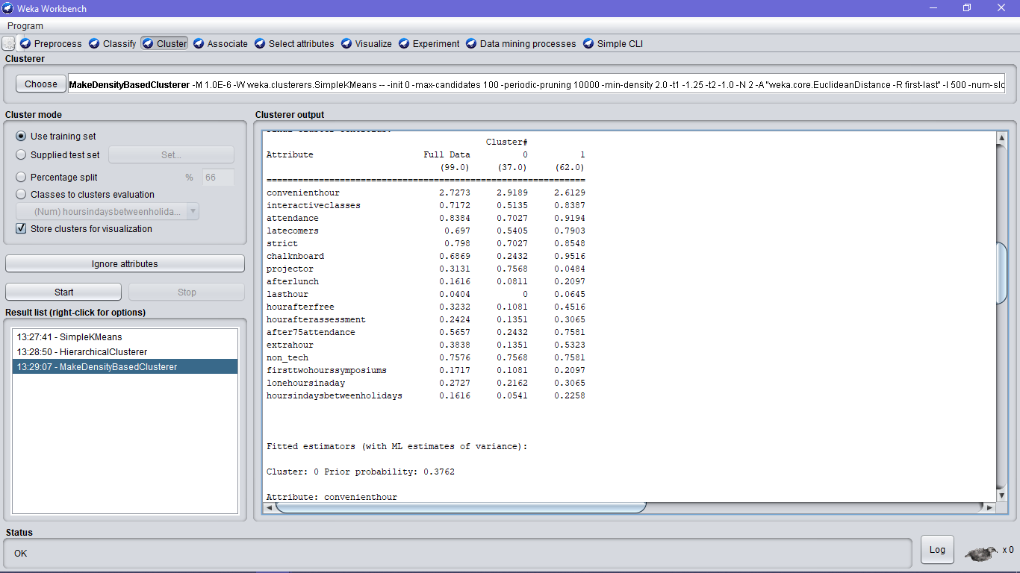

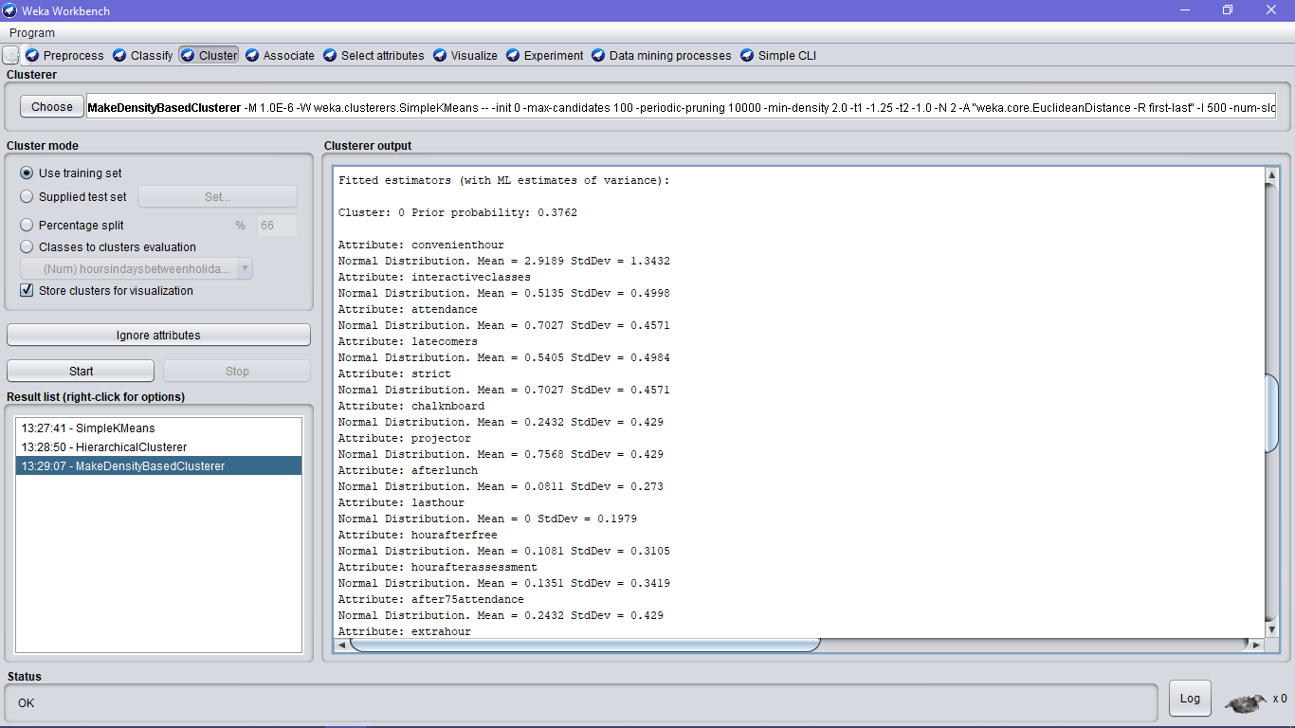

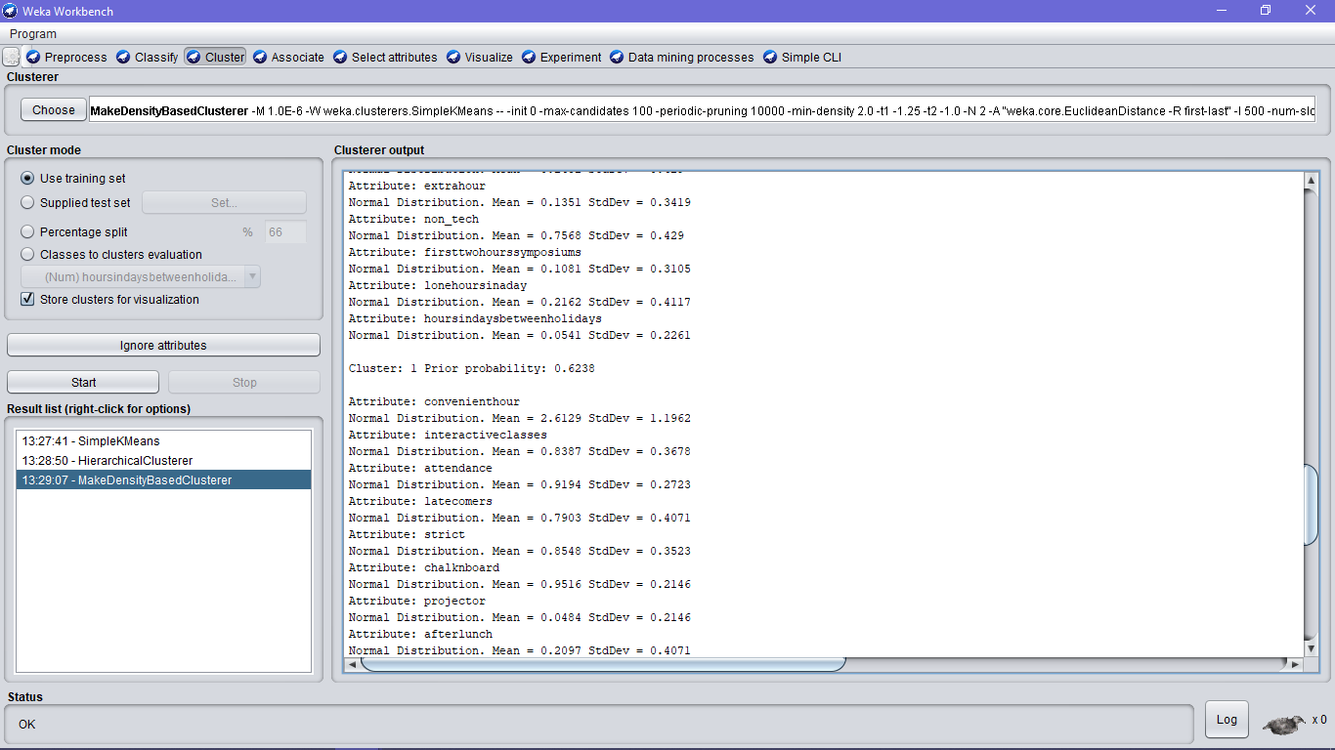

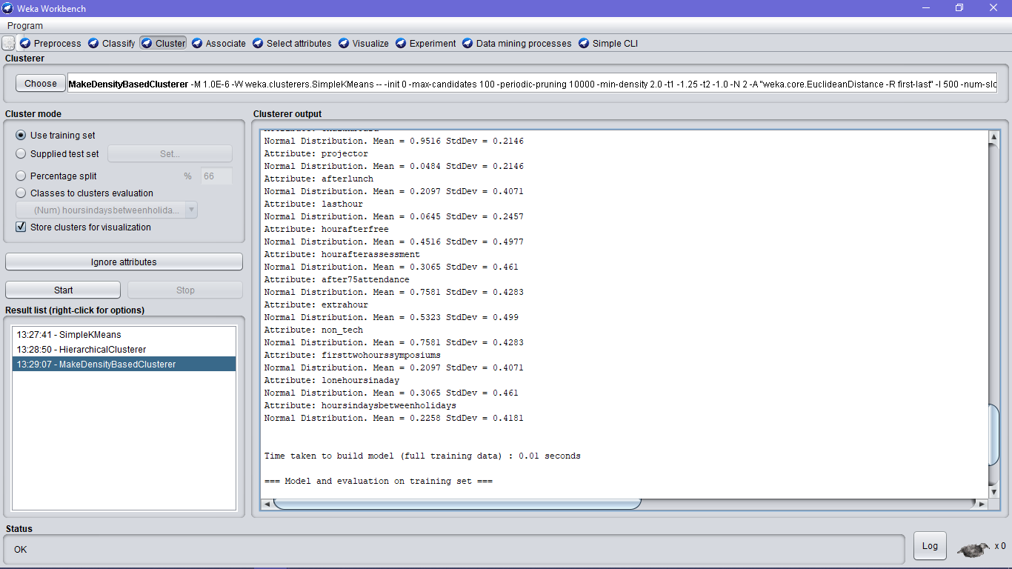

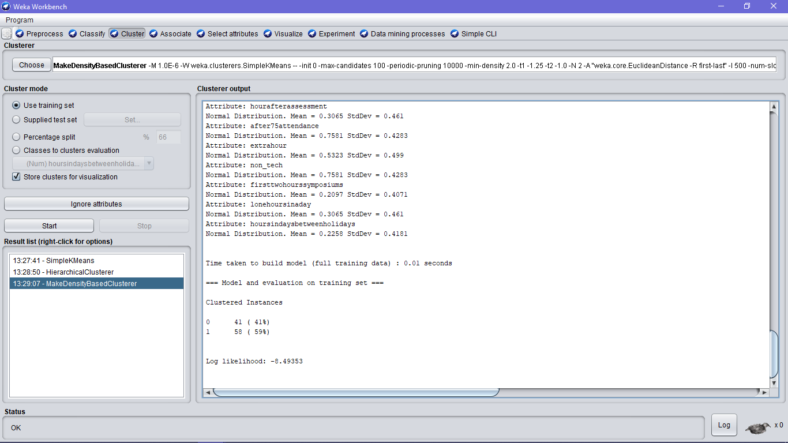

Here are the results of K-means clustering of the acquired dataset

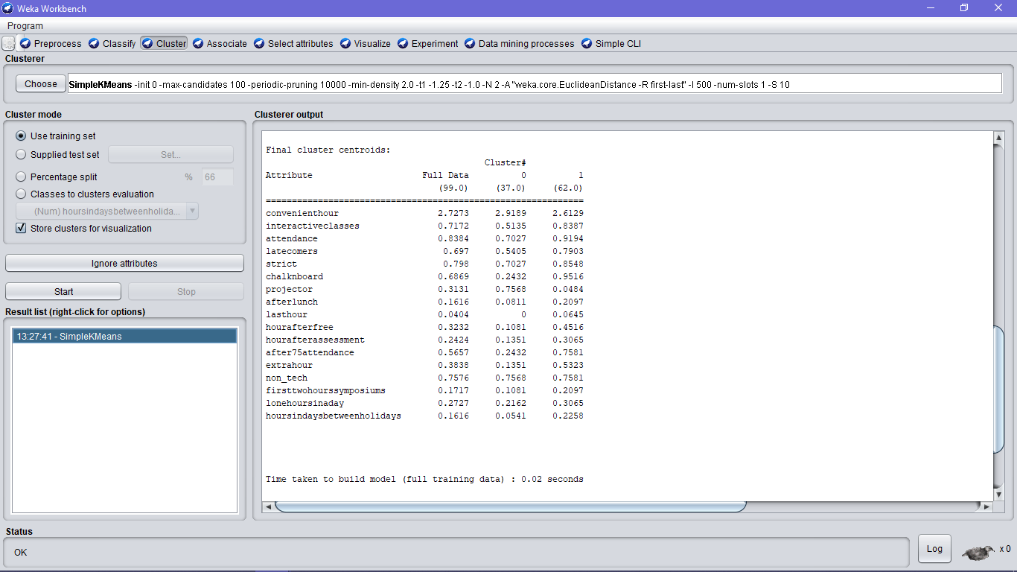

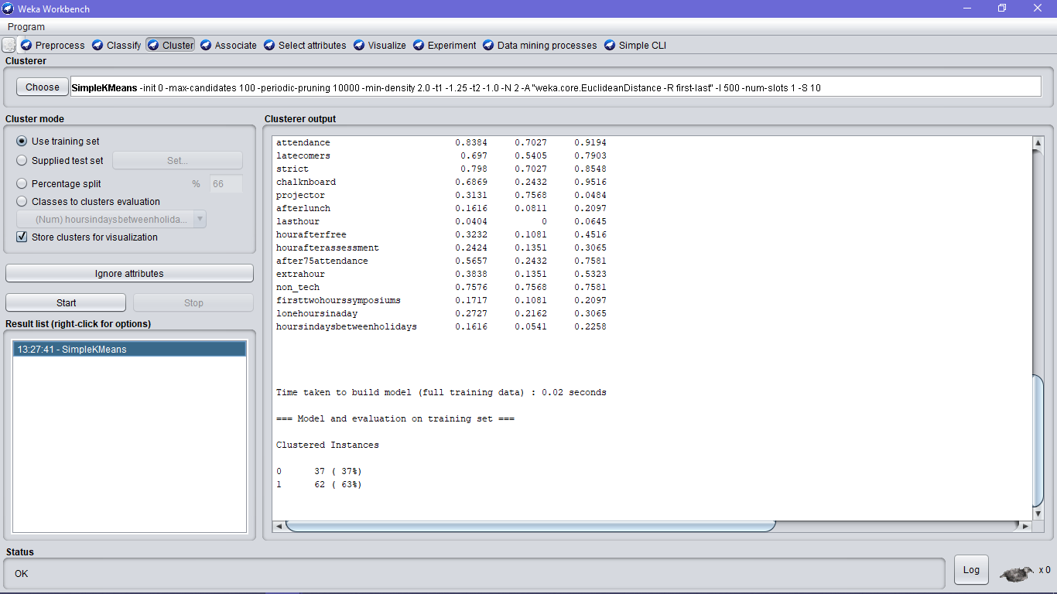

**Classification :**

The zeroR classification is done separately for each and every questions in the survey. The results for each questions are as follows

Will you to class if you have more than 75% attendance?

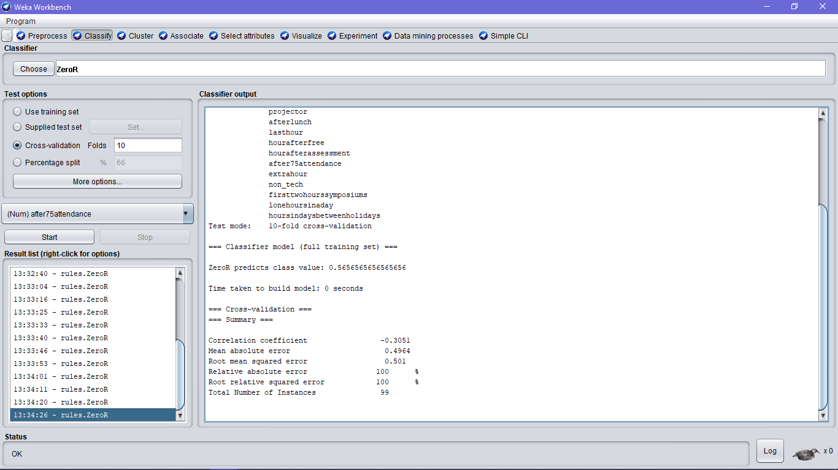

Will you attend the class conducted after assesment?

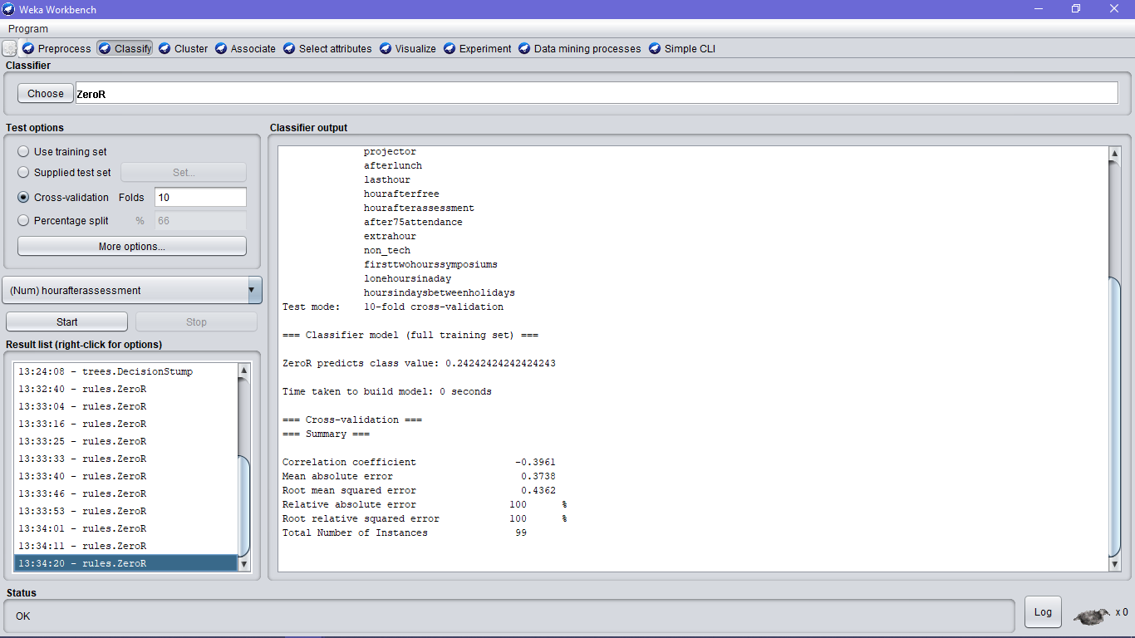

Will you attend a class conducted after a free hour?

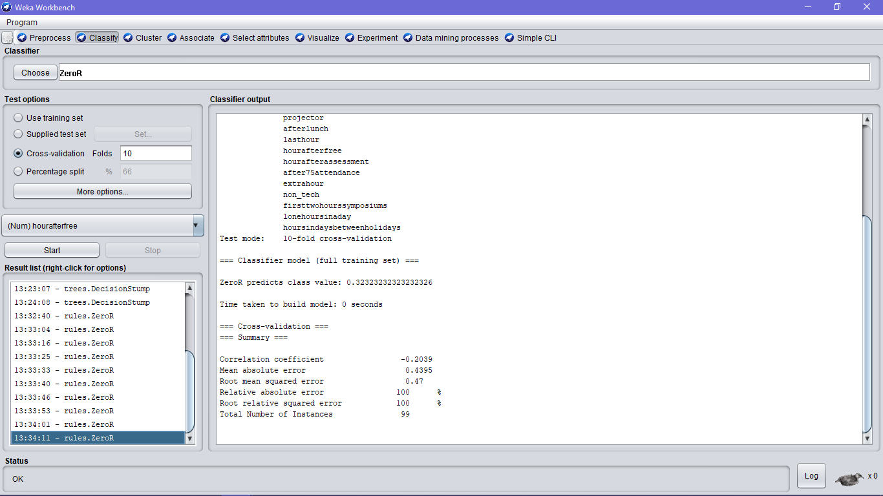

Will you attend a class conducted after lunch?

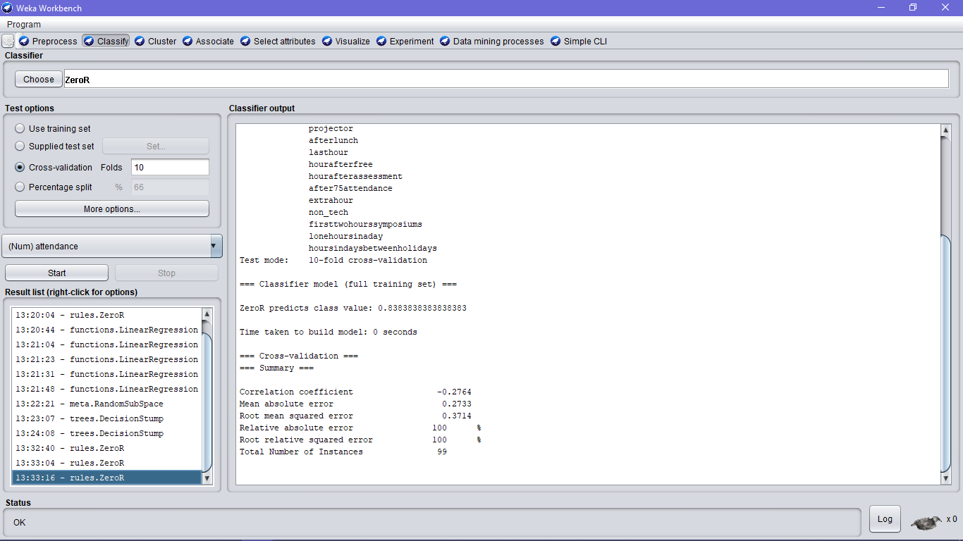

Will you go to the class if the staff is strict?

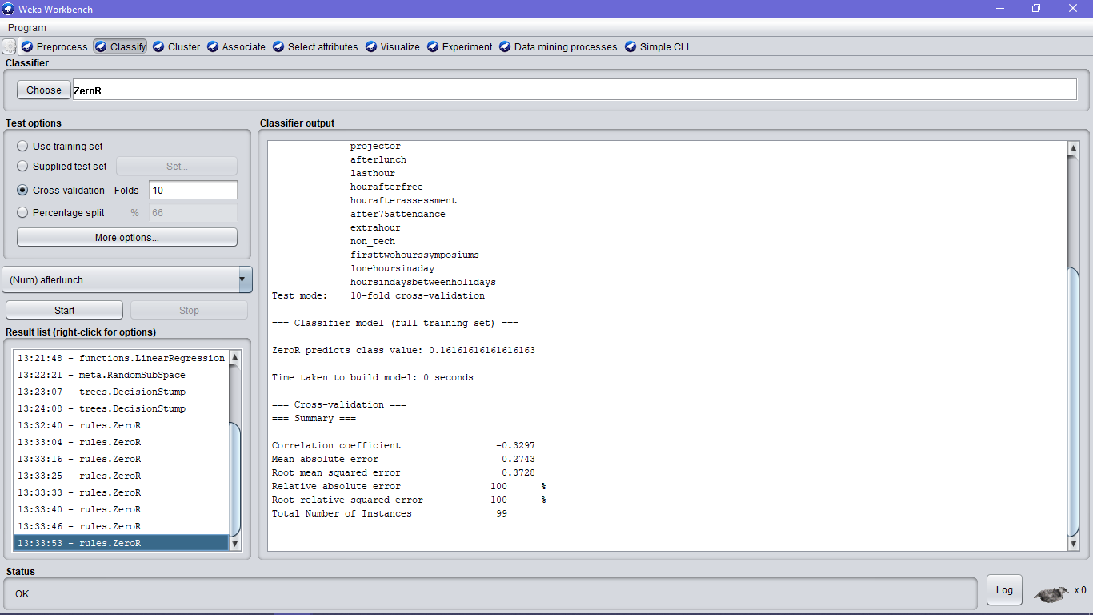

Prefer chalk and board in teaching?

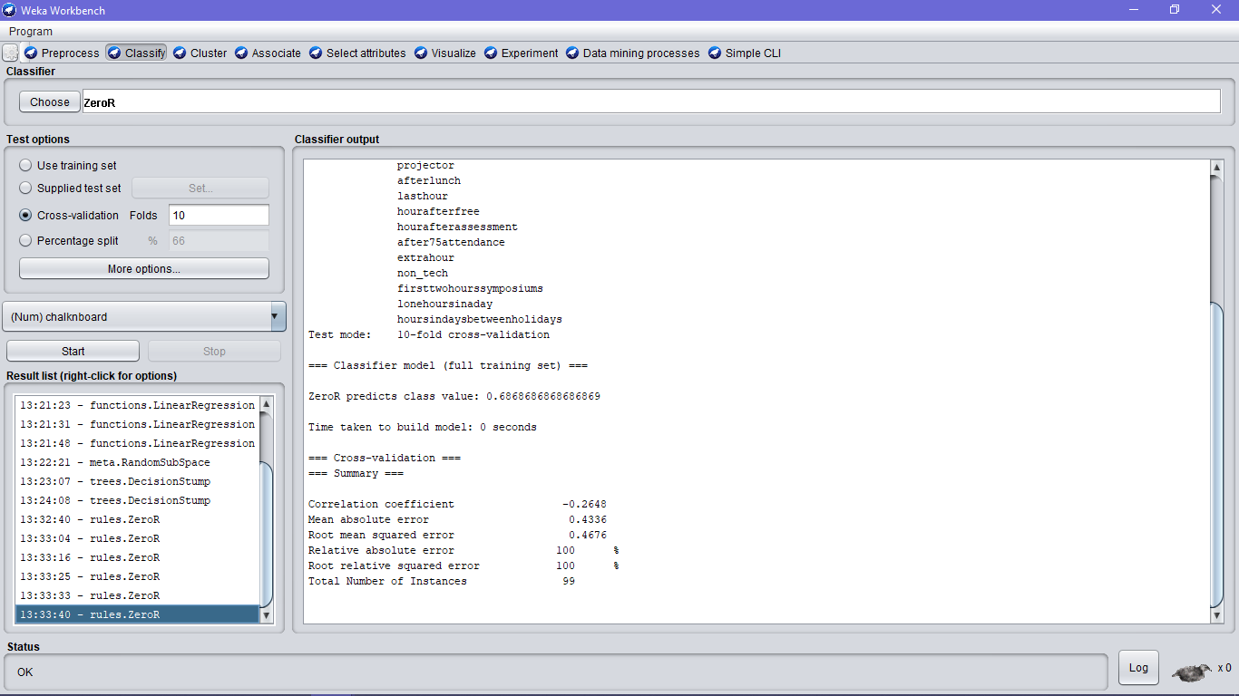

What is your convenient hour in attending class?

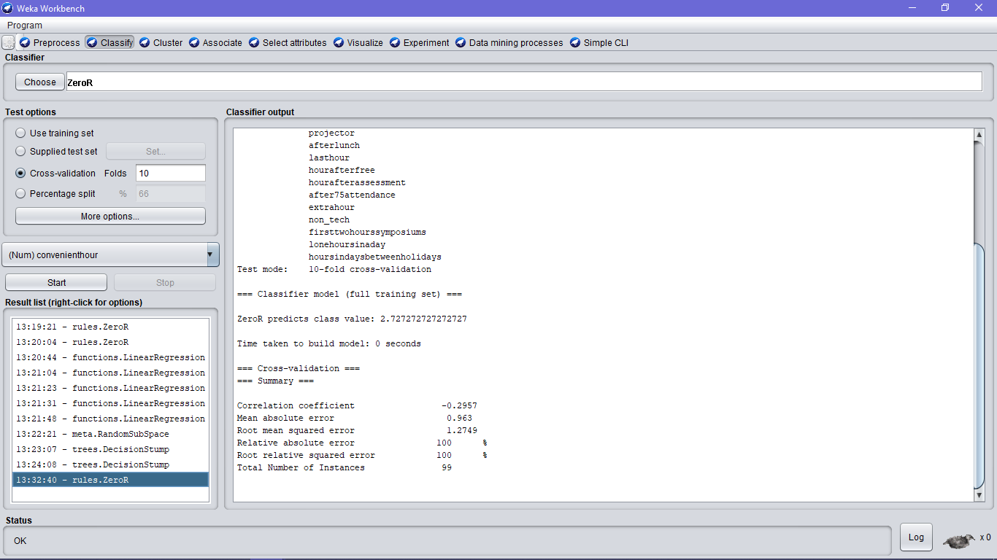

Will you attend extra hours conducted?

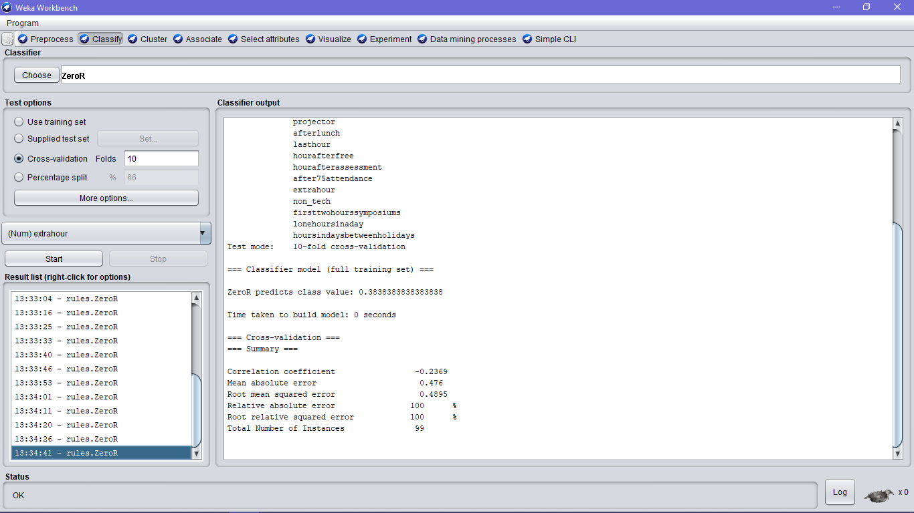

Will you attend class conducted in holidays?

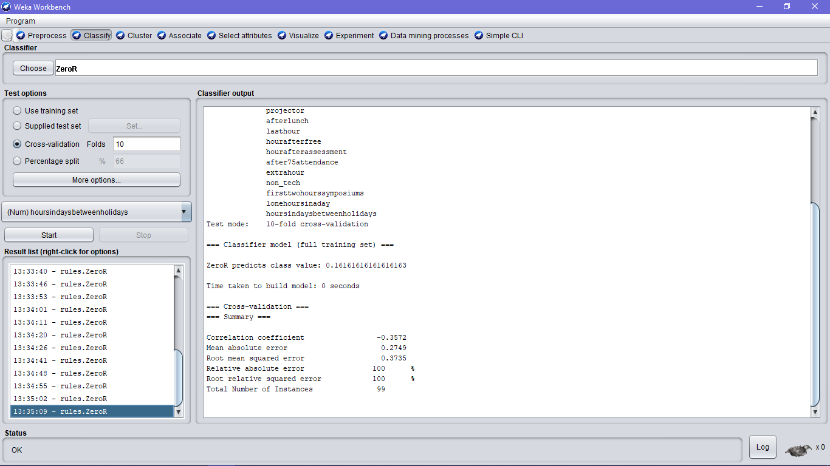

Prefer interactive activities in class?

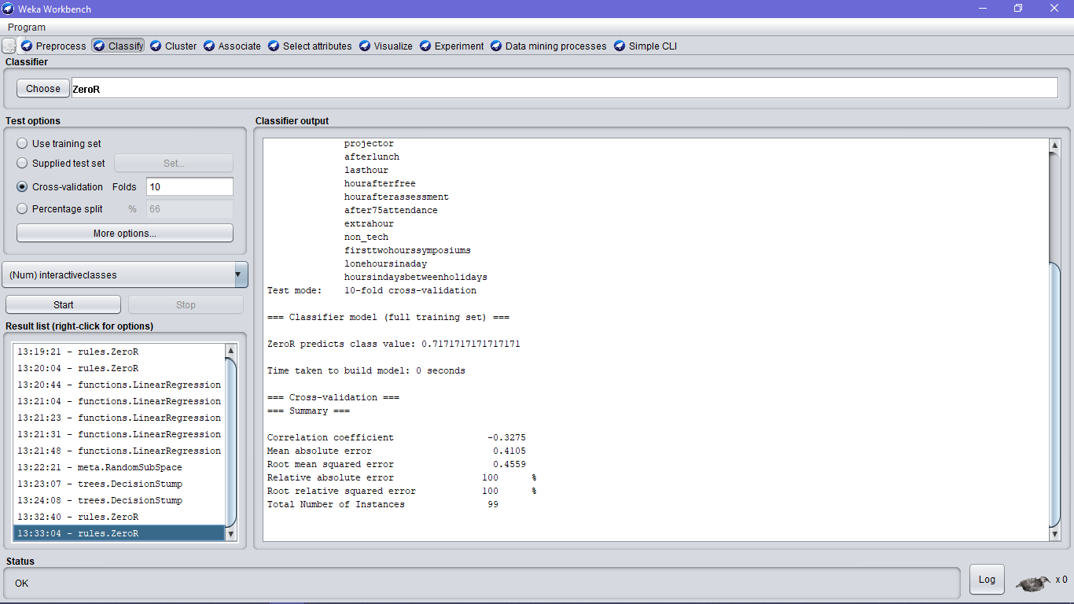

Prefer last hour class?

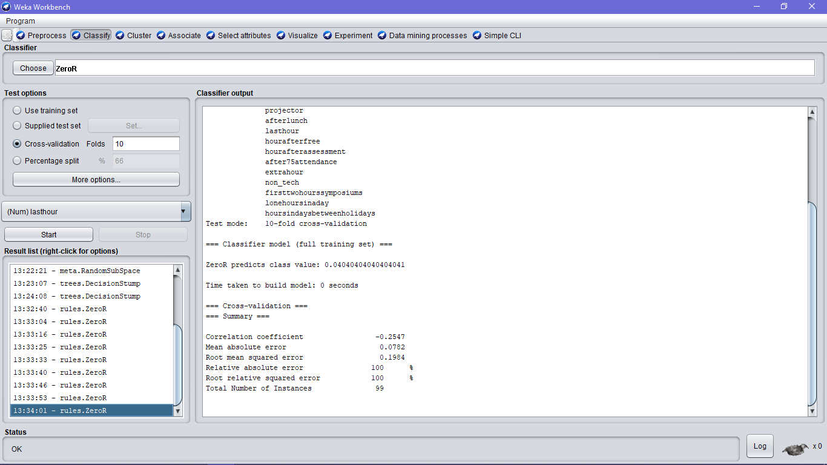

Will attend if staff is strict regarding late comers?

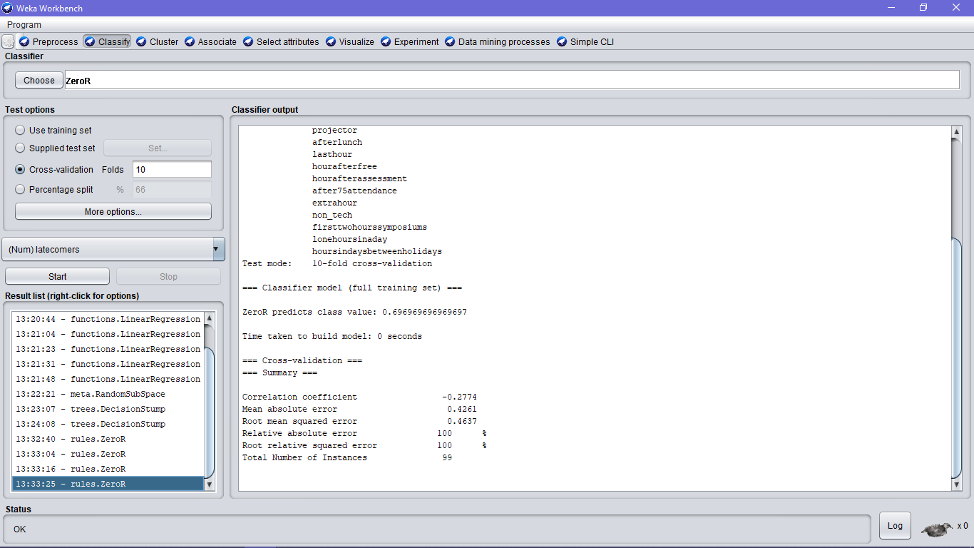

Will attend lone hours?

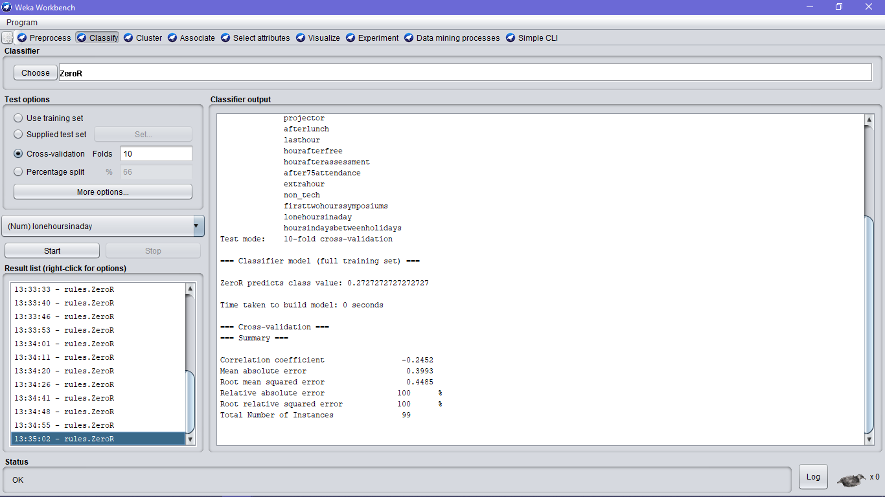

Prefer staff conducting non tech stuffs?

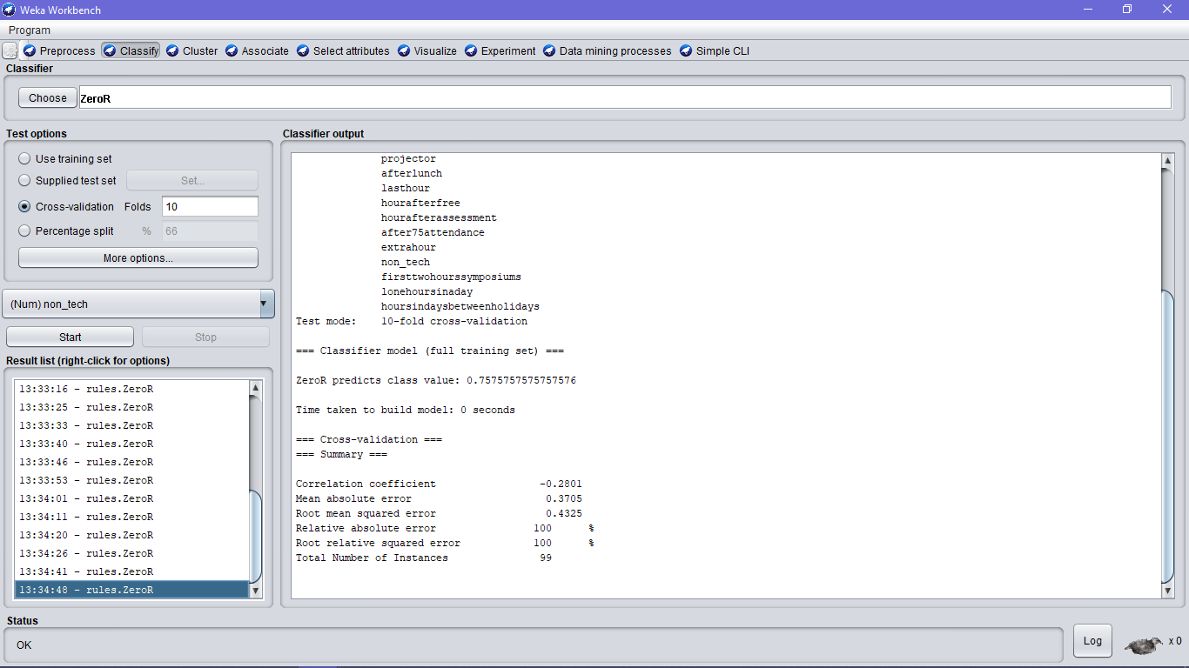

Prefer teaching via projector?

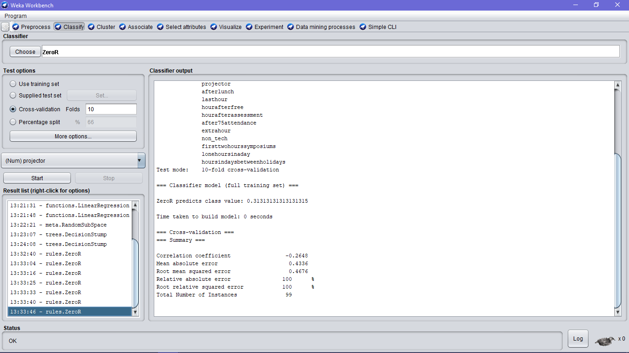

Prefer strict staff?

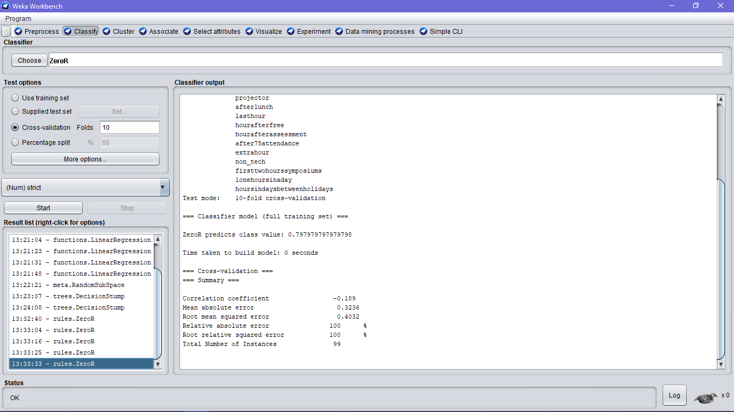

Will you attend class conducted in the symposium days?

